Online Bookstore System
SR | USER Requirements | GPT Results | VeriGen Results
 | The Customer must not be already registered. | MISSING | 1. The system shall provide customer with the ability to registeredThe system shall provide customer with the ability to click the register button on the home page.
 | The Customer clicks the Register button on the Home Page. | 3 The system shall provide the ability for users to click the Register button on the Home Page. | MISSING
 | The system displays the register page. | 4 If a user clicks the Register button, then the system shall be able to display the Register page. | 2. The system shall be able to display the register page.
 | The Customer registers all the required information. | 5 The system shall provide the ability for users to enter all required registration information on the Register page. | 3. The system shall provide customer with the ability to register all the required information.
 | The Customer clicks the send button. | 6 The system shall provide the ability for users to click the Send button after entering registration information. | 4. The system shall provide customer with the ability to click the send button.
 | The system checks that all of the required information was entered. | 7 If the Send button is clicked, then the system shall be able to check that all required registration information has been entered. | 5. The system shall be able to check that all of the required information entered.
 | If yes, then the system updates the customer’s record in the account tables in the database. | 9. If all required registration information is entered, then the system shall be able to update the customer’s record in the account tables in the database. | 6. If yes, then the system shall be able to update customers record in account tables in database.
 | System displays OK message. | 10 If the customer’s record is updated successfully, then the system shall be able to display an OK message to the user. | 7. The system shall be able to displays message.
 | The tables are updated by the system. | MISSING | 8. The system shall provide tables with the ability to updatedThe system shall provide customer with the ability to click the login button on the home page.
 | The Customer clicks the log-in button on the Home Page. | 14 The system shall provide the ability for users to click the Log-in button on the Home Page. | MISSING
 | The system displays the log-in page. | 13 The system shall provide the ability to display a Log-in button on the Home Page. | 9. The system shall be able to display the login page.
 | The customer enters his login Id with password. | 16 The system shall provide the ability for users to enter a login ID on the Log-in page.  17 The system shall provide the ability for users to enter a password on the Log-in page. | 10. The system shall provide customer with the ability to enter his login i d with password.
 | The customer clicks on the confirm button. | 18 The system shall provide the ability for users to click the Confirm button after entering login credentials. | 11. The system shall provide customer with the ability to click on the confirm button.
 | The system checks that all of the required information was entered. | 19 If the Confirm button is clicked, then the system shall be able to check that both login ID and password have been entered. | 12. The system shall be able to check that all of the required information entered.
 | If the entered information is wrong then system asks customer to reenter the details. | 20 If either the login ID or password is missing, then the system shall be able to display an error message indicating the missing information. | 13. If the entered information is wrong then the system shall be able to ask customer to reenter details.
 | The system validates the entered information against the tables stored in the database. | 21 If both login ID and password are entered, then the system shall be able to validate the credentials against the account tables in the database. | 14. The system shall be able to validate the entered information against the tables stored in the database.
 | The customer should be logged in. | 23 If the entered credentials are correct, then the system shall be able to log the user in. | 15. The system shall provide customer with the ability to logged in.
 | If the customer is not logged in then Log-in Usecase is carried out. | 24 If the user is not logged in, then the system shall be able to prompt the user to log in before proceeding with any restricted actions. | 16. If the customer is not logged in then the system shall be able to log login usecase carried out.
 | The customer enters the keyword for a book and clicks the search button on the Personal Home Page. | 25 The system shall provide the ability for logged-in users to enter a keyword for a book on the Personal Home Page. | - The system shall provide customer with the ability to enter the keyword for a book.  18. The system shall be able to clicks personal search button home page.
 | The system displays the matching books on the web Page. | 27 If the Search button is clicked, then the system shall be able to display matching books on the web page. | 19. The system shall be able to display the matching books on the web page.
 | The customer chooses the desired book. | 29 The system shall provide the ability for users to select a desired book from the search results. | 20. The system shall provide customer with the ability to choose the desired book.
 | He clicks the ADD TO SHOPPING CART button on the web page. | 30 The system shall provide the ability for users to click the ADD TO SHOPPING CART button for a selected book. | 21. The system shall be able to clicks add shopping cart button web page.
 | The system adds the book into the CUSTOMER’s Order table in the database. | 31 If the ADD TO SHOPPING CART button is clicked, then the system shall be able to add the selected book to the customer’s Order table in the database. | 22. The system shall be able to add the book in to the customers order table in the database.
 | The customer can directly go on the checkout page, CheckOut use case is carried out. | 33 The system shall provide the ability for users to navigate directly to the checkout page from the shopping cart. | 23. The system shall provide customer with the ability to directly go on the checkout page , checkout use case carried out.
 | The customer must be logged-in. | MISSING | 24. The system shall be able to loggedinIf the customer is not logged in then the system shall be able to log login usecase carried out.
 | If the customer is not logged in then Log-in Usecase is carried out. | MISSING | MISSING
 | The customer selects sell used books on the homepage. | 35 The system shall provide the ability for users to select the "Sell Used Books" option on the Home Page. | 25. The system shall provide selects with the ability to sell used books on the homepage.
 | The system shows sell used books webpage. | 36 If the "Sell Used Books" option is selected, then the system shall be able to display the Sell Used Books web page. | 26. The system shall be able to show sell used books webpage.
 | The customer enters all the details of the books to sell- name, publication, type etc. | 37 The system shall provide the ability for users to enter all details of the books to sell, including name, publication, and type. | 27. The system shall provide customer with the ability to enter all the details of the books to sell name , publication , type etc.
 | The system displays a confirmation page listing the information that the customer has entered. | 40 After entering book details, the system shall be able to display a confirmation page listing the entered information. | 28. The system shall be able to display a confirmation page listing the information that the entered.
 | The customer checks the displayed information is correct. | MISSING | 29. The system shall provide customer with the ability to check the displayed information correct.
 | If the information is not accurate then the customer corrects the information. | 42 The system shall provide the ability for users to correct any inaccurate information on the confirmation page. | 30. If the information is not accurate then the system shall be able to correct customer information.
 | The customer clicks on the OK button to confirm. | 43 The system shall provide the ability for users to click the OK button to confirm the sale of the used book. | 31. The system shall provide customer with the ability to click on the ok button to confirm.
 | The customer must be logged-in. | MISSING | 32. The system shall be able to loggedinIf the customer is not logged in then the system shall be able to log login usecase carried out.
 | If the customer is not logged in then Login Usecase is carried out. | MISSING | MISSING
 | The customer checks for the desired book , clicks on the chosen book icon. | MISSING | 33. The system shall provide customer with the ability to desired chosenThe system shall be able to display the books detail in the book detail web page.
 | The system displays the book’s detail in the Book Detail web page. | 47 If a book icon is clicked, then the system shall be able to display the book’s details on the Book Detail web page. | MISSING
 | The CUSTOMER clicks the REVIEW button on the web page. | 48 The system shall provide the ability for users to click the REVIEW button on the Book Detail web page. | 34. The system shall provide customer with the ability to click the review button on the web page.
 | The system displays the Review Book web page. | 49 If the REVIEW button is clicked, then the system shall be able to display the Review Book web page. | 35. The system shall be able to display the review book web page.
 | The CUSTOMER clicks on the desired star button. | 50 The system shall provide the ability for users to select a star rating for the book on the Review Book web page. | 36. The system shall provide customer with the ability to click on the desired star button.
 | Then clicks the OK button on the web page. | 51 The system shall provide the ability for users to click the OK button to submit their book review. | 37. The system shall be able to clicks ok button web page.
 | The system calculates the overall rating of the book, updates the Book table in the database. | 52 If the OK button is clicked on the Review Book page, then the system shall be able to calculate the overall rating of the book. | 38. The system shall be able to calculate the overall rating of the book , updates the book table in the database.
 | The system displays the Book Detail web pages that have been updated. | 54 After updating the Book table, the system shall be able to display the updated Book Detail web page to the user. | 39. The system shall be able to display the book detail web pages that updated.
 | The system displays the selected books to the customer. | 55 The system shall provide the ability for users to view the selected books in their shopping cart. | 40. The system shall be able to display the selected books to the customer.
 | The customer checks the order list of any inconsistency. | 56 The system shall provide the ability for users to check the order list for inconsistencies. | 41. The system shall provide customer with the ability to check the order list of any inconsistency.
 | If nothing is found, then the customer clicks on the proceed button. | 58 If no inconsistencies are found, then the system shall provide the ability for users to click the Proceed button to continue. | 42. If nothing is found, then the system shall be able to click customer on proceed button.
 | The system shows the invoice page. | 59 If the Proceed button is clicked, then the system shall be able to display the invoice page. | 43. The system shall be able to show the invoice page.
 | The customer enters the address for delivery of the selected books. | 60. The system shall provide the ability for users to enter a delivery address on the invoice page. | 44. The system shall provide customer with the ability to enter the address for delivery of the selected books.
 | He click on the proceed button. | 61 The system shall provide the ability for users to click the Proceed button after entering the delivery address. | 45. The system shall be able to click proceed button.
 | The customer enters the credit/debit card information. | 62. The system shall provide the ability for users to enter credit/debit card information for payment. | 46. The system shall provide customer with the ability to enter the creditdebit card information.
 | If the information entered by the customer is incorrect then transaction is aborted. | 64 If the credit/debit card information is incorrect, then the system shall be able to abort the transaction. | 47. If the information entered by the customer is incorrect then the system shall be able to abort transaction.
 | The system confirms the receipt. | 67 If the payment is successful, then the system shall be able to confirm the receipt to the user. | 48. The system shall be able to confirm the receipt.
 | The customer downloads the receipt. | 68 The system shall provide the ability for users to download the receipt after a successful transaction. | 49. The system shall provide customer with the ability to download the receipt.
 |  | 8 If any required registration information is missing, then the system shall be able to display an error message indicating which fields are missing.
 |  | 11 The system shall be able to prevent registration if the customer is already registered.
 |  | 12 If the customer is already registered, then the system shall be able to display an error message indicating that the customer already exists.
 |  | 14 The system shall provide the ability for users to click the Log-in button on the Home Page.
 |  | 15 If the Log-in button is clicked, then the system shall be able to display the Log-in page.
 |  | 22 If the entered credentials are incorrect, then the system shall be able to display a message asking the user to re-enter the details.
 |  | 26 The system shall provide the ability for users to click the Search button after entering a keyword.
 |  | 28 If no matching books are found, then the system shall be able to display a message indicating that no results were found.
 |  | 32 The system shall be able to display a confirmation message when a book is successfully added to the shopping cart.
 |  | 34 If a user attempts to access the checkout page without being logged in, then the system shall be able to prompt the user to log in.
 |  | 38. The system shall provide the ability to validate that all required fields for selling a book are entered.
 |  | 39 If any required field for selling a book is missing, then the system shall be able to display an error message indicating the missing information.
 |  | 41 The system shall provide the ability for users to review the confirmation page for accuracy.
 |  | 53. The system shall be able to update the Book table in the database with the new rating.
 |  | 44 If the OK button is clicked, then the system shall be able to update the database with the used book sale information.
 |  | 45 If a user attempts to sell a book without being logged in, then the system shall be able to prompt the user to log in.
 |  | 46 The system shall provide the ability for users to view the details of a selected book by clicking on the book icon.
 |  | 1 The system shall provide the ability to display the Home Page to users.
 |  | 2 The system shall provide the ability to display a Register button on the Home Page.
 |  | 69. The system shall be able to log all registration, login, book search, cart, checkout, and book sale activities for audit purposes.
 |  | 70. The system shall be able to handle and log all errors and exceptions encountered during user interactions.
 |  | 71. The system shall provide clear, context-sensitive feedback messages for all successful and unsuccessful actions.
 |  | 72. The system shall ensure that all sensitive customer information is securely transmitted and stored in the database.
 |  | 73. The system shall provide session management to ensure that only authenticated users can access personal and transactional pages.
 |  | 74. The system shall automatically log out users after a period of inactivity for security purposes.
 |  | 75. The system shall provide the ability for users to recover forgotten passwords via a secure process.
 |  | 76. The system shall provide the ability for users to update their personal information after logging in.
 |  | 77. The system shall validate all user inputs for format, length, and allowed characters before processing.
 |  | 78. The system shall provide the ability for users to view their order history after logging in.
 |  | - 79. The system shall provide the ability for users to remove books from the shopping cart before checkout.
 |  | - 80. The system shall provide the ability for users to update the quantity of books in the shopping cart before checkout.

Class Diagram (GPT)

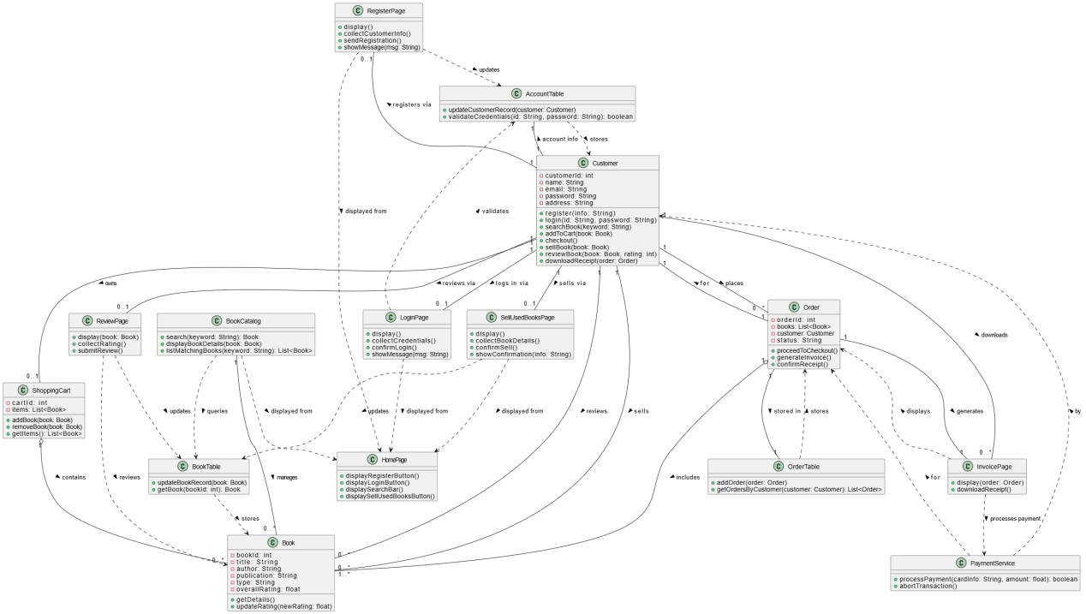

Class Diagram (VeriGen)

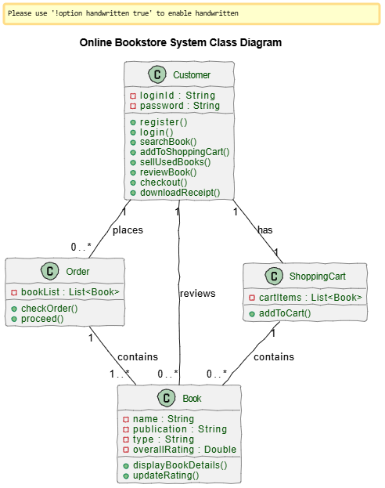

Sequence Diagram (VeriGen)

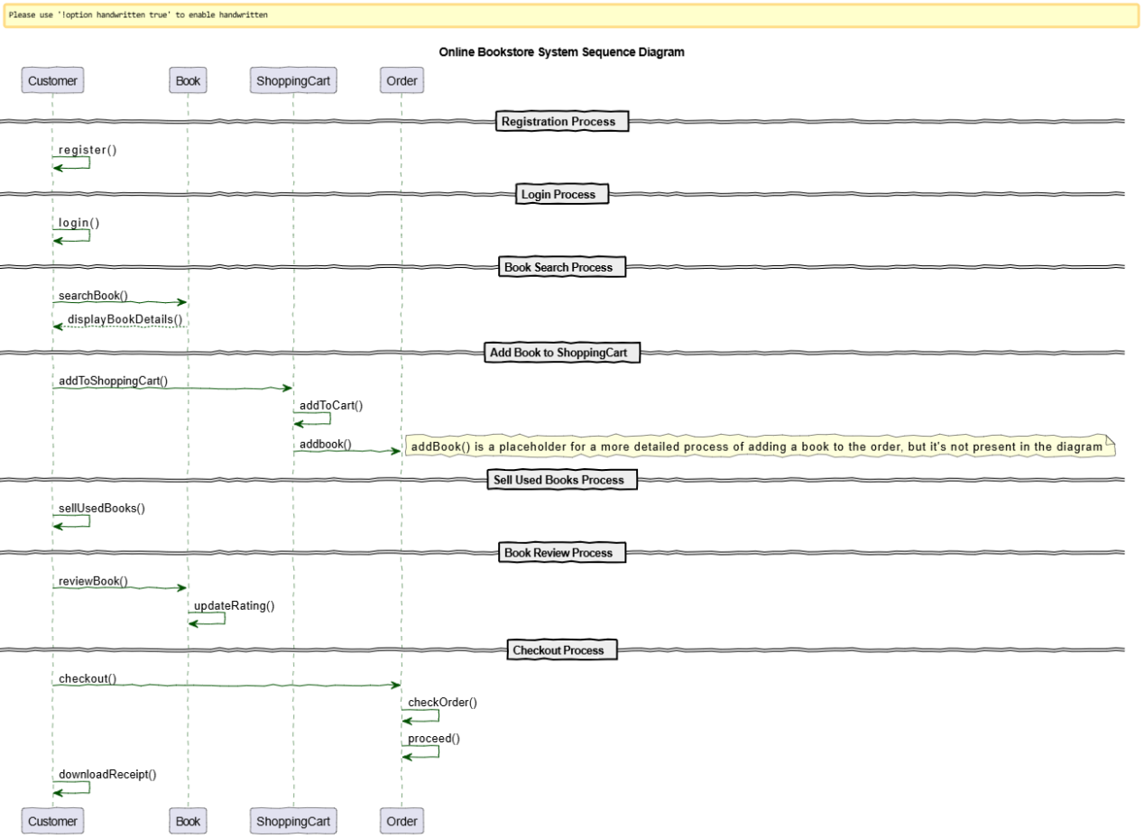

Sequence Diagram (GPT)
